Lothian Running Club Festive Handicap 2019

1 lap = 7km (approx) To Linlithgow

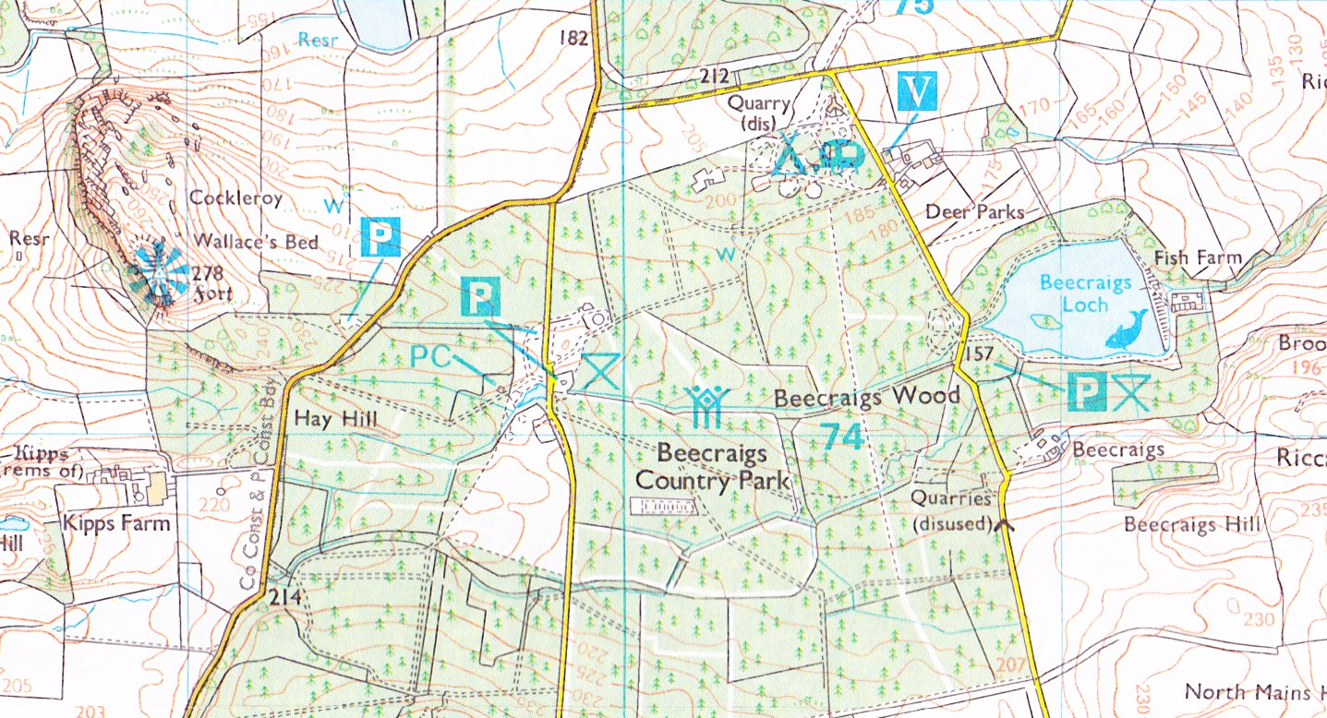
M
M
Start and Finish area
M
M
M
M
M

To Bathgate Race Route M = Marshal points

