Lothian Running Club Festive Handicap 2013 - Amended

1 lap = 7km (approx) To Linlithgow

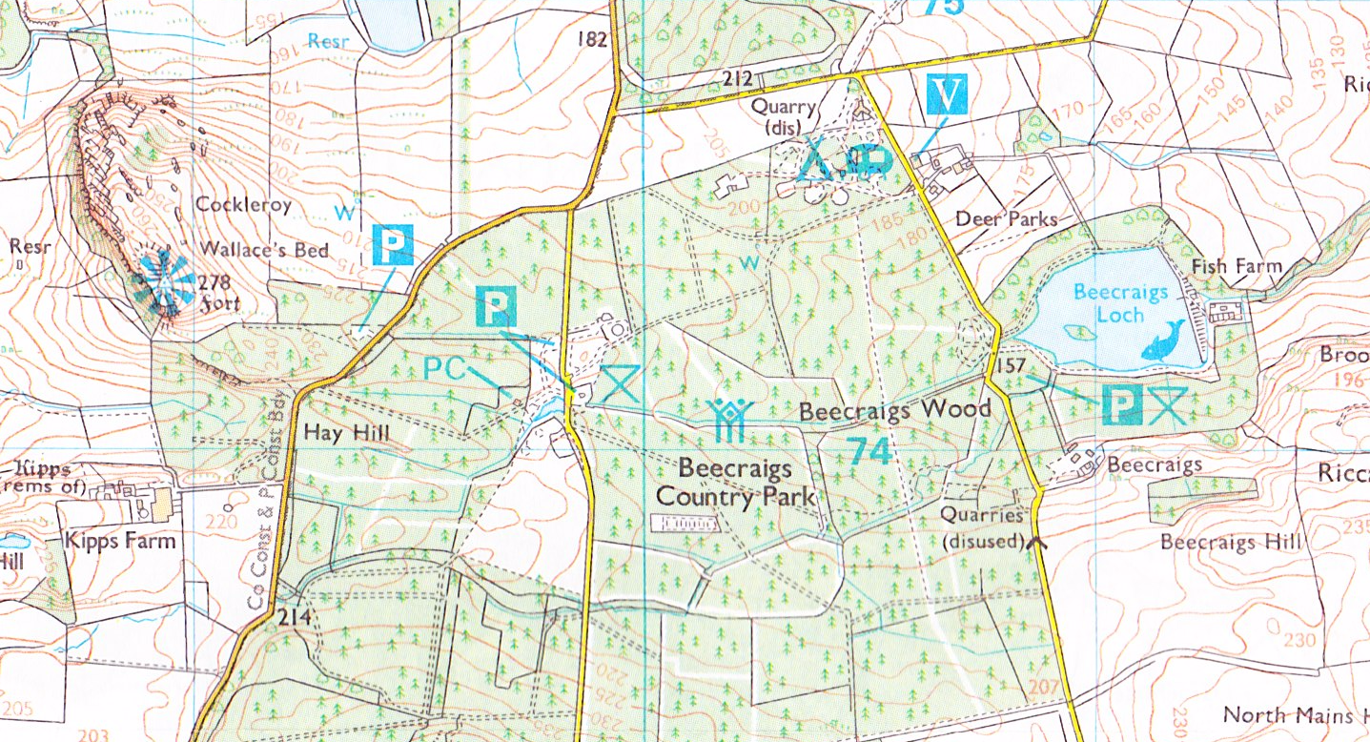
Start and Finish area

To Bathgate Race Route Note some sections are ‘2 way.’ Route subject to possible change
Changes to route for 2013 (as at 18:00 on 23.12.13) Further changes possible on day

